01/16/2024

>sudo unlink link

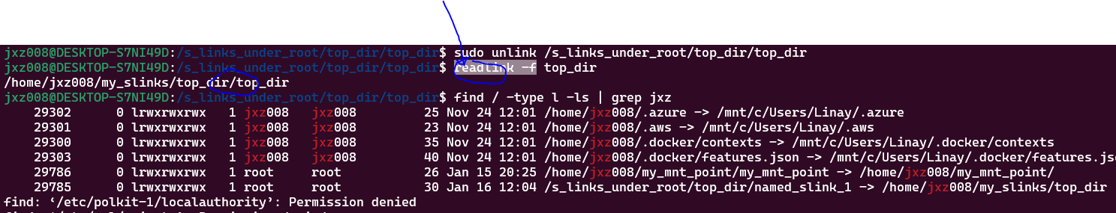

>readlink cmd is not good may still read cache?

Tested, you may unlink your mnt-point even the file from you src is open!

On the other hand, if your file (via the slink) is open in your dest dir, you may not be able to unlink your slink without any warnings! However, if you close your opened file, it will ‘catch up’ and then release and clean up this slink!

Side Note:

There are may be other reasons that you cannot unlink. If you know what you are doing, you can simply use rm –f to remove your slink from your dest dir. In the case it’s an oops, then you can re-create your slinks like connecting/disconnecting cycle without much harm!

If you cannot unlink, it may be a mount point which is similar but may not be the same and so disallow you to unlink as –

